**Raspi HP1020 User Guide**

This user guide introduces how to setup a new HP1020 printer server with raspi-hp1020 image.

The default account for this raspi-hp1020 image is:

Username: pi

Password: raspberry

Use it once the system asks for.

3 Steps

1. Login to local CUPS admin web. 1

2. Add printer 1

3. Test printer function. 5

# Login to local CUPS admin web.

1. Connect HP1020’s USB to Pi, power on the printer and the Pi(with image raspi-hp1020)

Wait until the Pi’s desktop appears. If the desktop is not appeared, open it manually with below command:

* startx

1. Open the Internet browser (double click on icon Midori on desktop), entering the URL: <http://127.0.0.1:631/admin>

# Add printer

1. Click button “Add Printer”

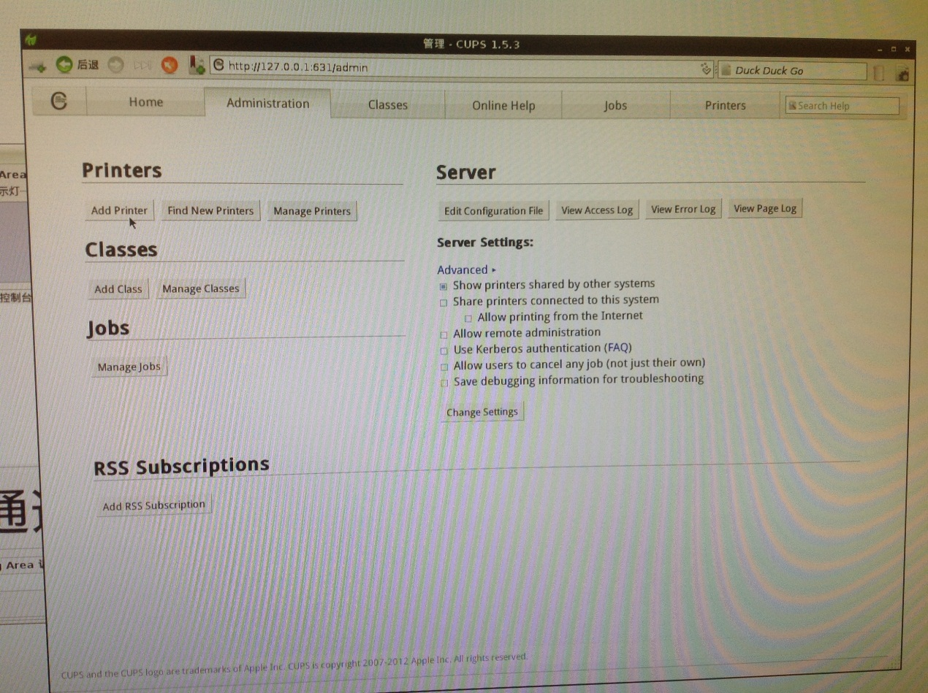

1. Select “HP LaserJet 1020 *” from “**Local Printers**” list and press button “continue”.

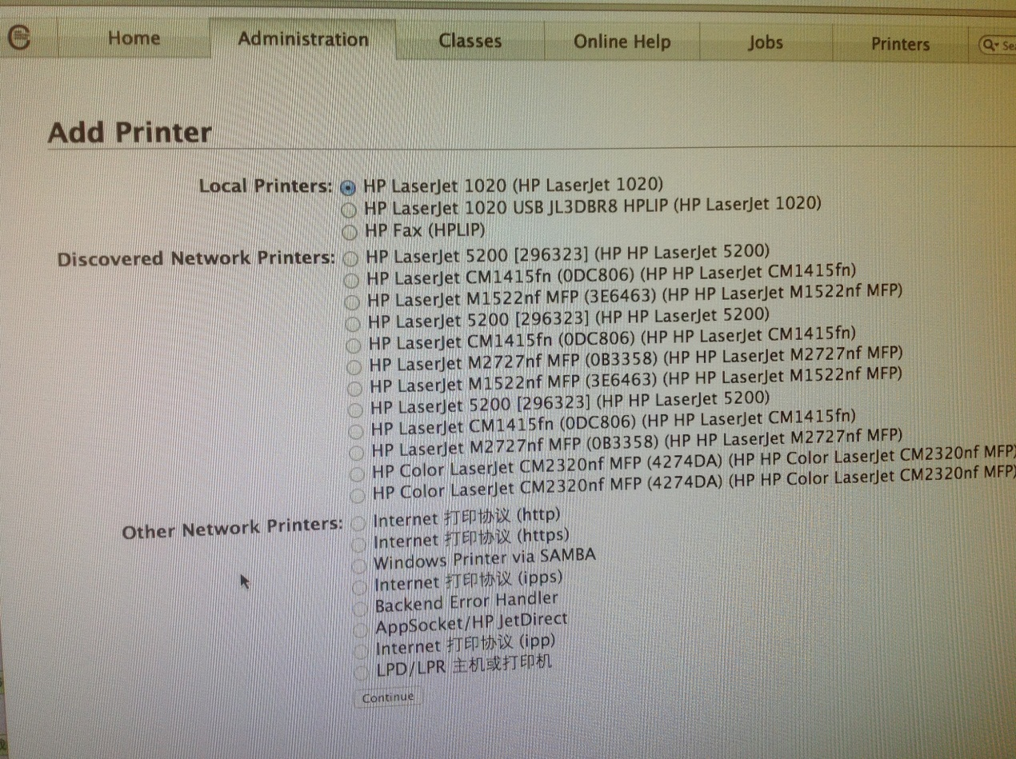

1. Add description for this printer in detail. \***IMPORTANT**\* check the option “Share This Printer”. Then click button “continue”.

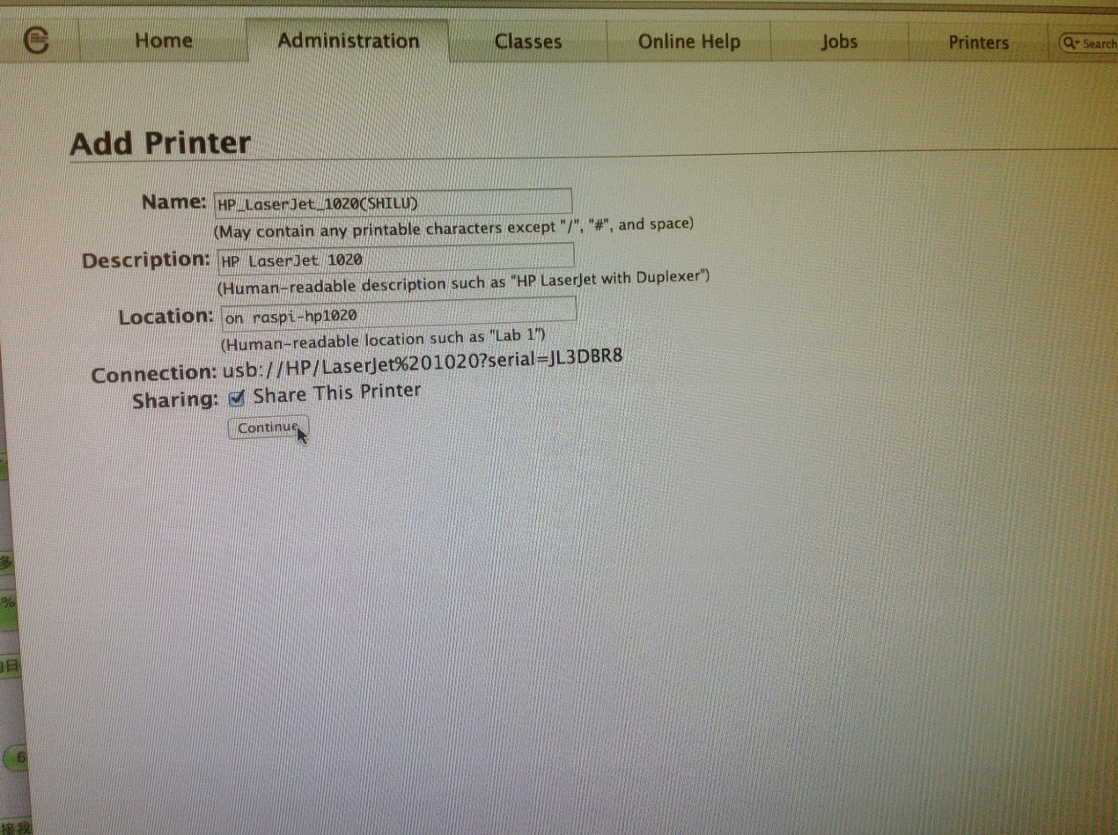

1. Select HP in “**Make**” list and press button “continue”.

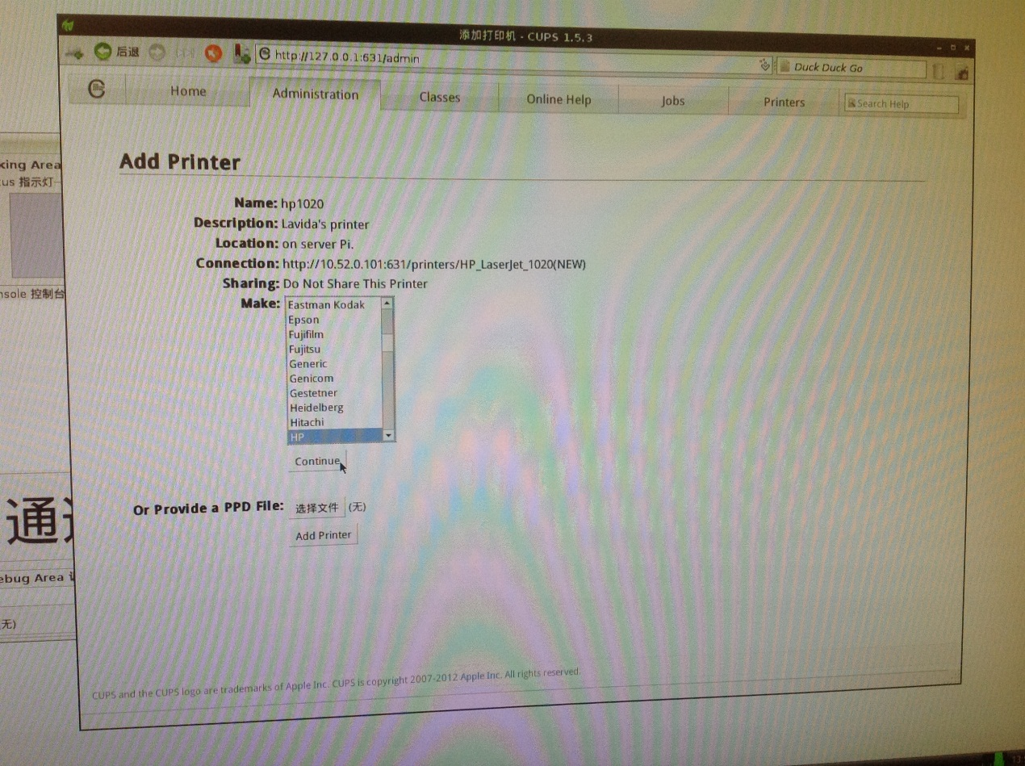

1. Select “HP LaserJet 1020 Foomatic/foo2zjs-z1 (recommended)(en) in “**Model**” list and press button “Add Printer”.

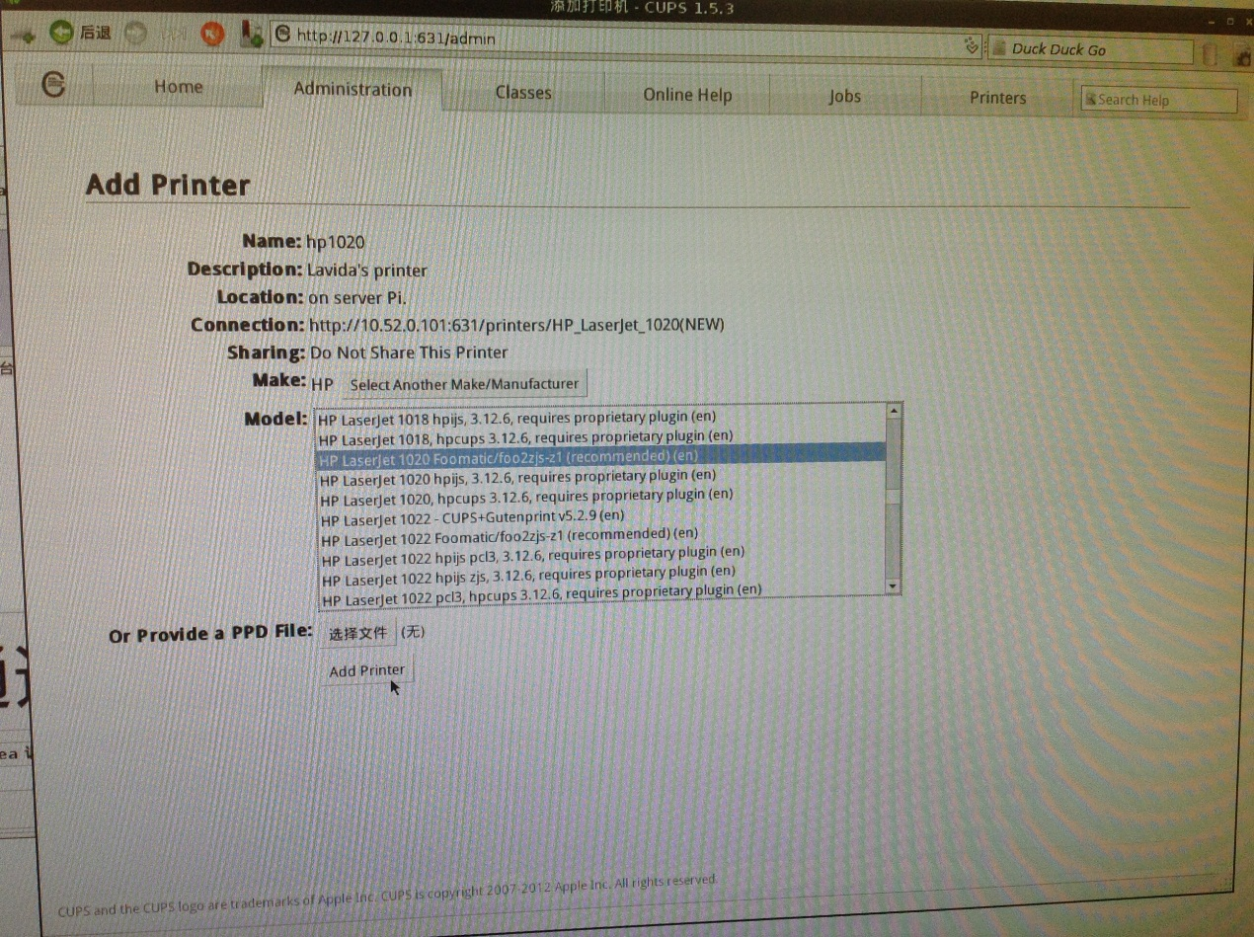

1. Press button “Query Printer for Default Options”

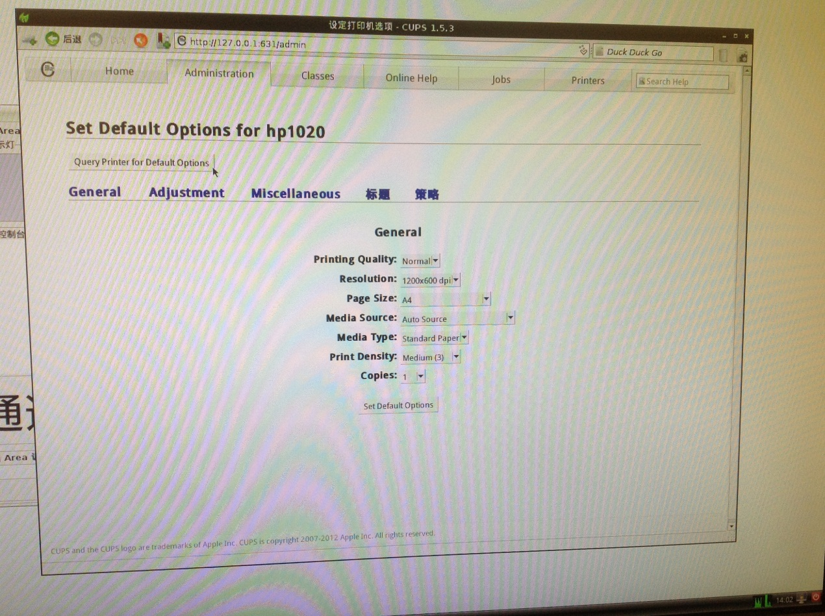

1. Click “Printers” tab and check if the printer has been added correctly.

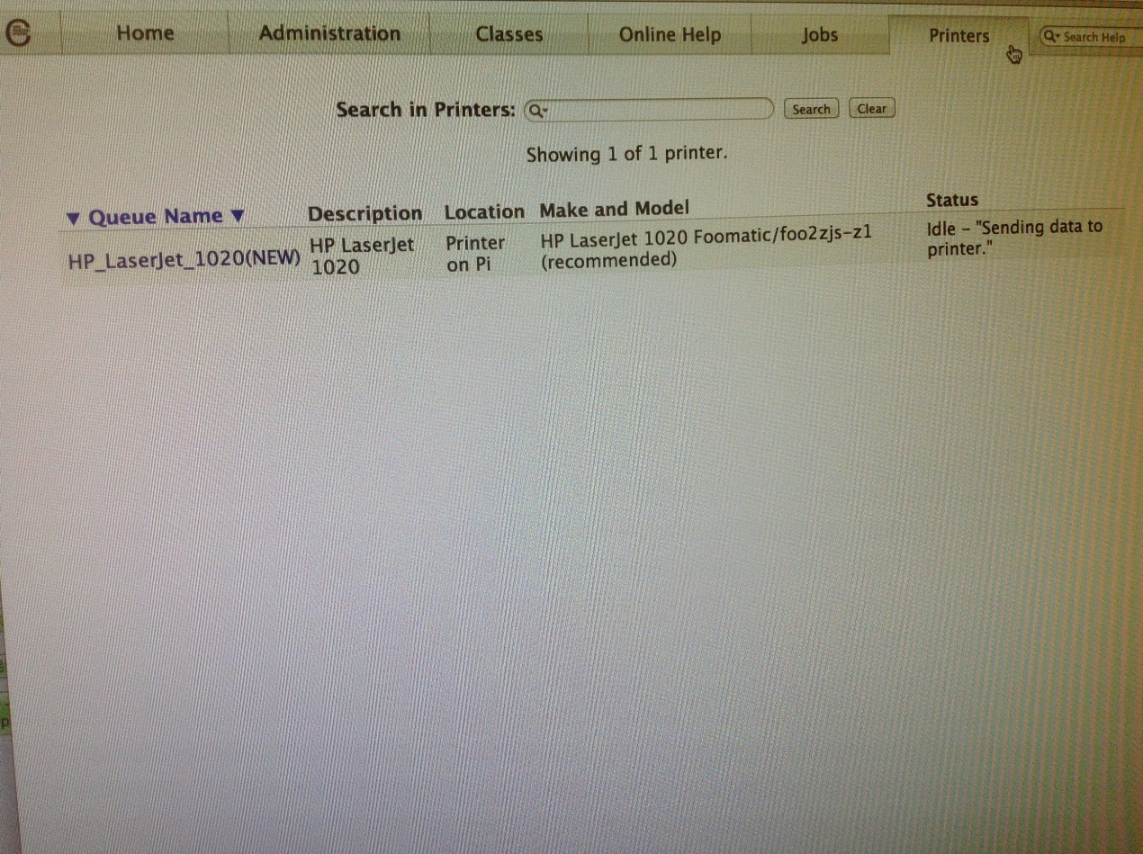

# Test printer function.

* 1. Double click on the icon “Lavida calitool” on desktop and open the debug window by press button “Debug”, then press button “Print”. After the window “Scanning the S/N” appears, press button “Printer Setup”.

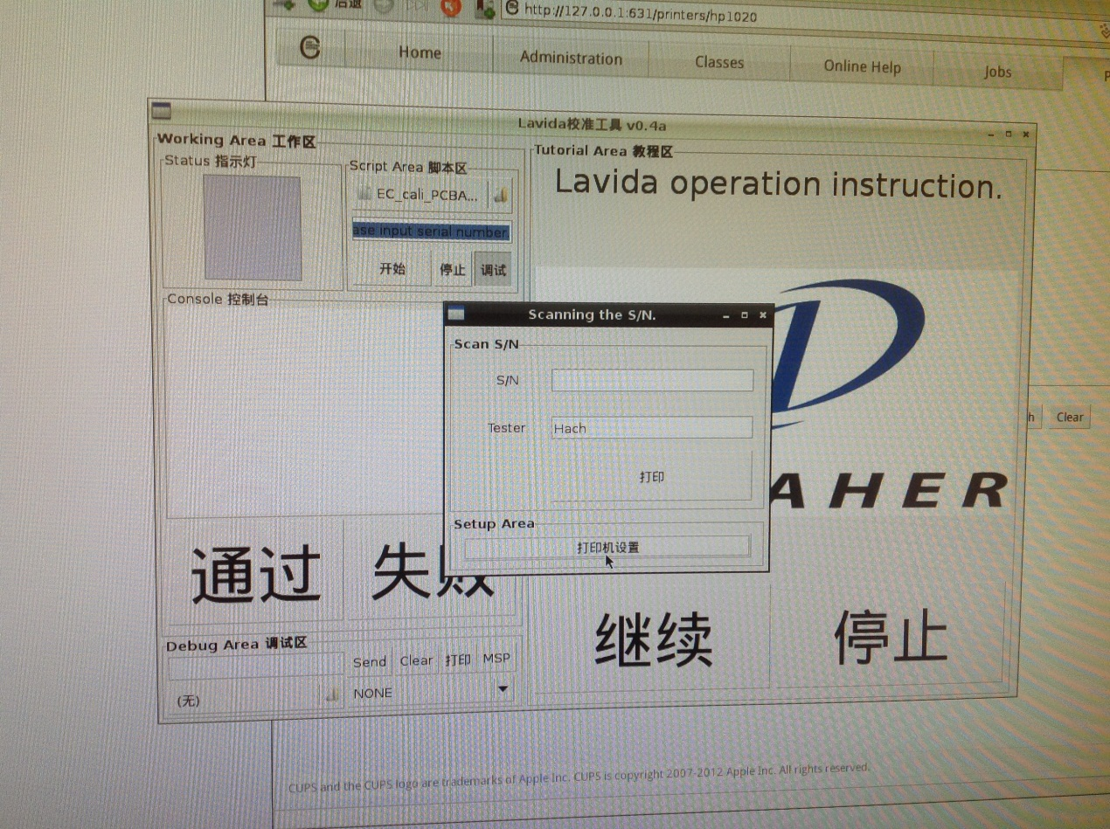

* 1. If the printer has been installed correctly in Step 2. The Pi will automatically find out the printer. Select the printer and click print.(this will not cause printing immediately but just save your choice)

\***MAKE SURE**\* the printer Pi and the client Pi should be in the same subnet. E.g. All the Pi’s IP should inside 192.168.1.1/254. Otherwise, you will need to add the printer for all client Pi manually with printer server Pi’s IP address.

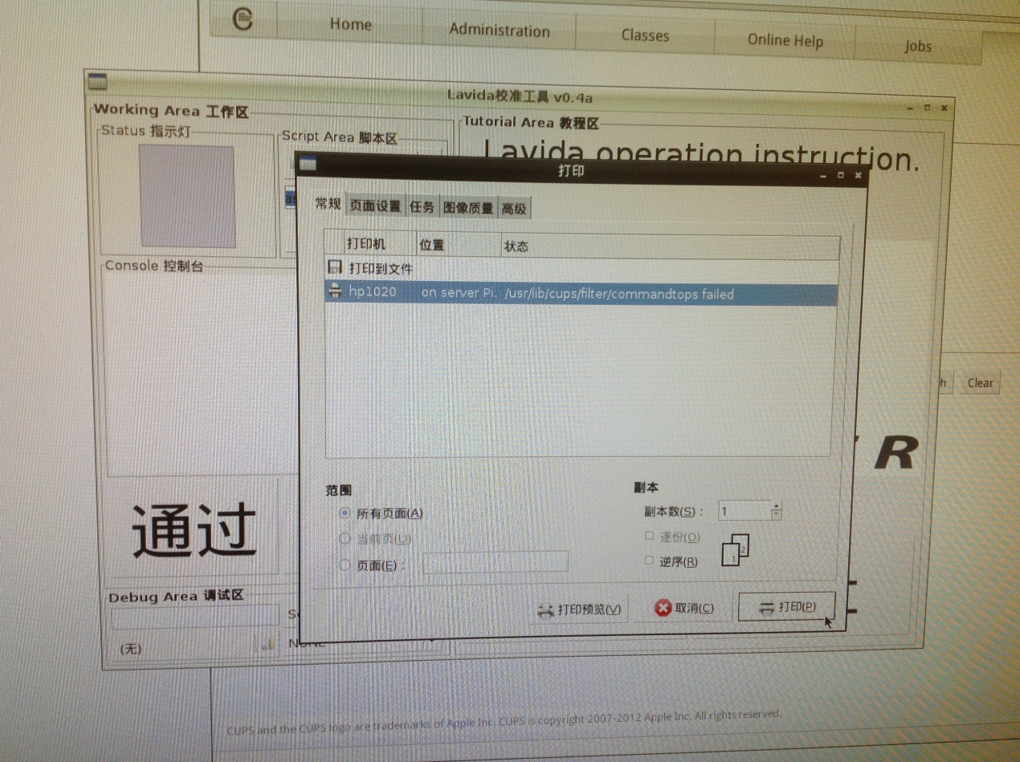

* 1. Give a number to S/N text box and press button “Print”

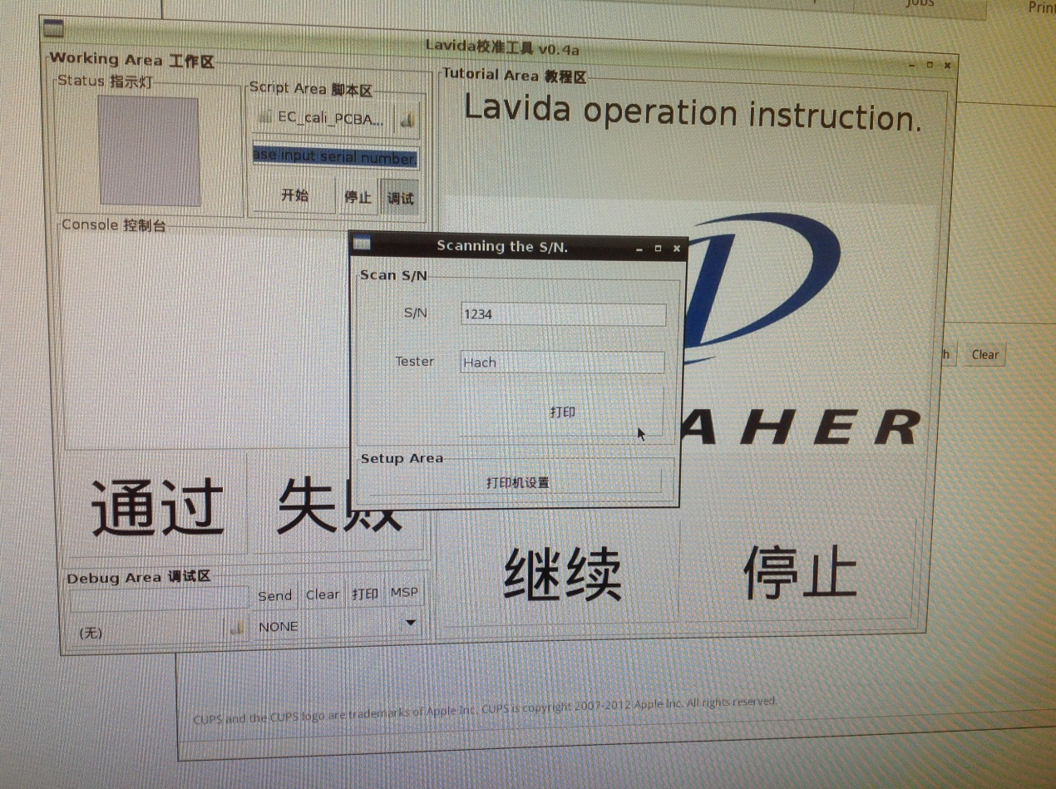

* 1. The certification page will be print correctly

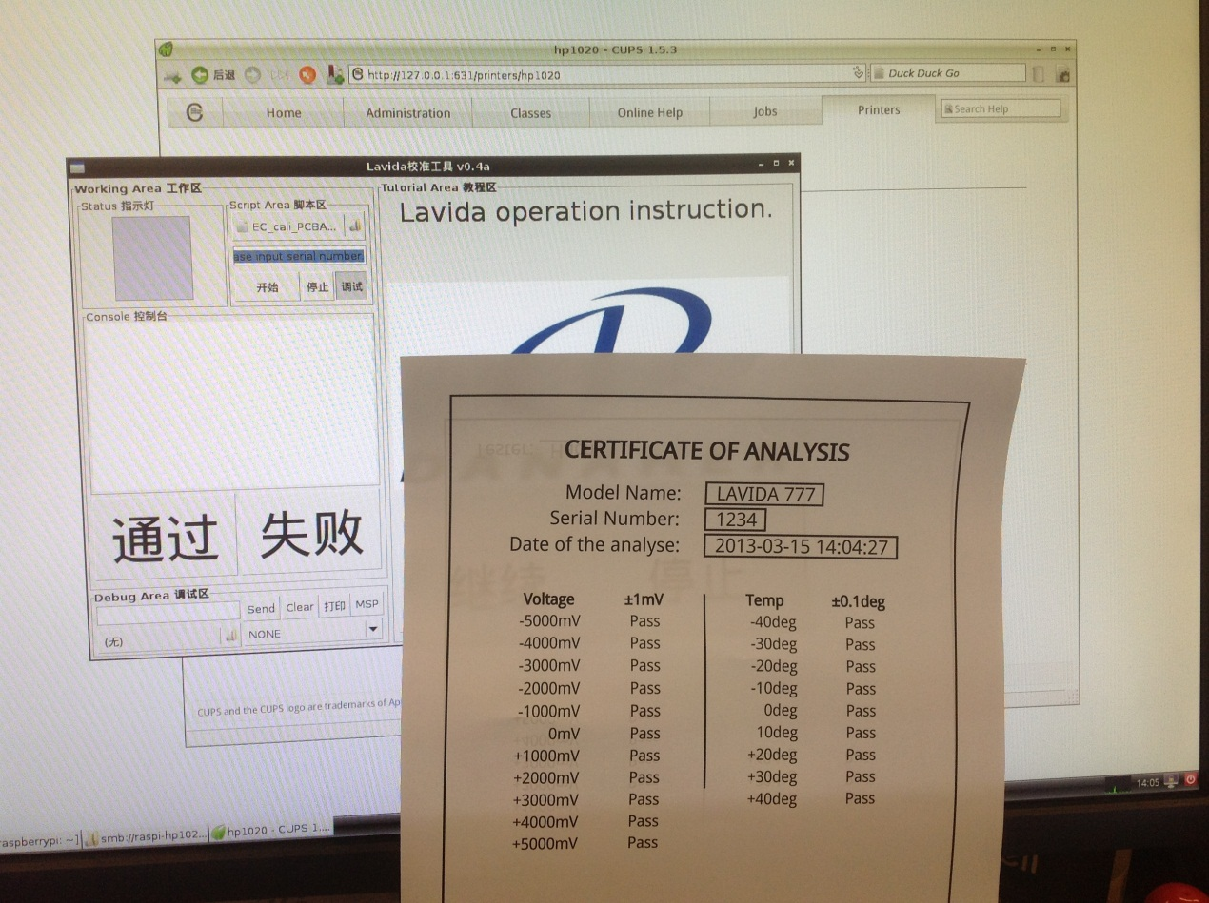

* 1. Print from client Pi.

It is same with printing from printer server Pi in above step.

# Trouble shooting

* 1. If you have just purchased a new HP1020 and want to make this new printer as an alternate for current printer, this guide is written for you.
  2. Before you adding the new printer, you should delete current printer by entering printer management page.

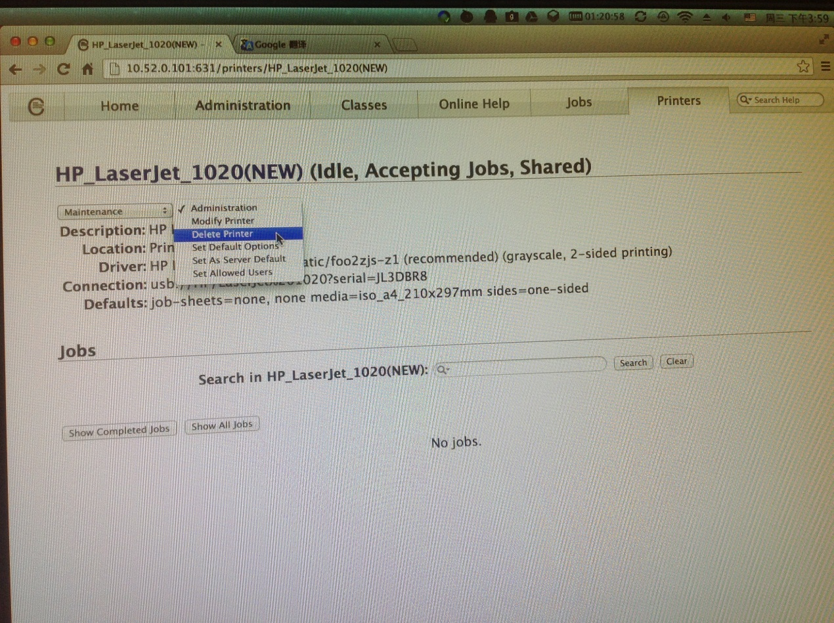

* 1. If you want to add other brand printer, or different HP model instead of HP1020, please query Apple Inc. for detail.

<http://www.cups.org/>